**Project Name:** TM Master Web Application

Software Requirements Specification Document

‘TRUSTING MINDS’

Web Application

Made By

Divyansh Kumar Mahavar

HACKVEDA

Creation Date:

03/03/2023

**1. Introduction**

A software requirements specification (SRS) is **a document that describes what the software will do and how it will be expected to perform**. It also describes the functionality the product needs to fulfill the needs of all stakeholders (business, users)

**1.1 Purpose**

To Develop Web Application that aids hospital in converting manual process into digital process. It also helps to develop personalized plans for patients and enable fast and reliable communication between stakeholders.

**1.2 Scope**

The web application aims to digitize the manual processes used in hospitals. Chefs, patients, and doctors can now collaborate and communicate more effectively thanks to the software. The application's primary goal is to enhance patient healthcare by enabling physicians to create tailored meal regimens for individuals based on their medical problems.

**1.2 Stakeholders**

Patients: Allows to book appointment and fill required details to receive evaluation and personalized meal plans for health.

Doctors: Allows to doctor to study report and collaborate with patients and chefs to provide more reliable and fast services.

Chefs: Allows chefs to collaborate with doctors and patients to prepare personalized diet food which ensures patient’s health.

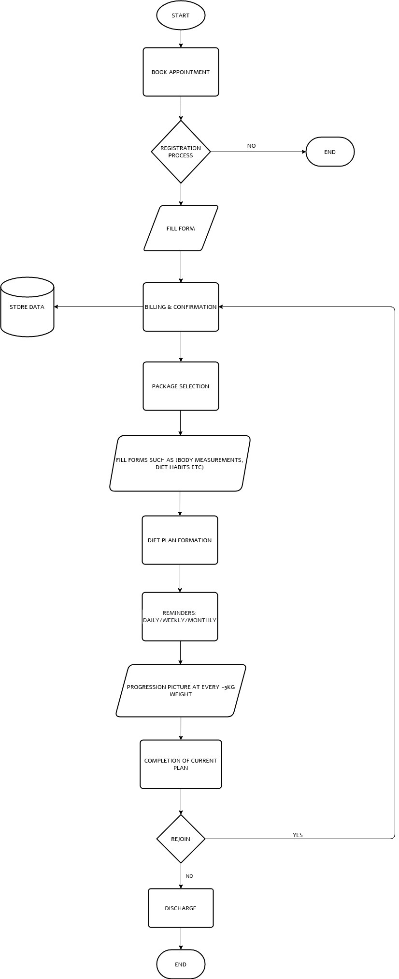FLOWCHART:

**2. FUNCTIONAL REQUIREMENTS:**

**2.1 Patient Evaluation**

By completing the patient assessment form in the web application, doctors can assess the condition of their patients. Doctors also have access to the patient's medical background and history, along with other pertinent information.

**2.2 Patient Data Management**

Doctors can store and access patient data using the web application's patient record management feature. Such as patient diagnosis, medication information, and other information through the application.

**2.3 Culinary Interface**

The web application also offers a culinary interface that enables them to watch the patient's dietary needs and adjust their menus appropriately. By ensuring collaboration between doctors, patients, and chef, the application makes sure that patients receive the appropriate diet as per medical situation.

**2.4 Individual Diet Programme**

Doctors can develop specialized diet plans and publish them on the website application based on the patient's medical condition. Based on the patient's state, the application gives doctors a list of suggested foods.

**2.5 Communication Interface**

The web application facilitates better communication between chefs, doctors, and patients. With the help of the application's messaging function, doctors, patients and chefs can make sure they are have same understanding and provide their best services without any mishaps.

**3. NON-FUNCTIONAL REQUIREMENTS:**

**3.1 Performance**

Provide reliable performance to all stakeholders. The Web Application should be fast, reliable, and should be able to perform well under huge loads continuously.

**3.2 Security**

Web Application should be secured to prevent DDOS attacks and prevent data leakage. Patient data should be stored using Encryption methods to safeguard their privacy and keep confidentiality.

**3.3 User Friendly**

Web Application should be User Friendly to provide rich experience. It should also be easy to navigate and responsive.

**WEB APPLICATION FUNCTIONS**

* **Book Appointment**
  + Client Title
  + Client Name
  + Session Type:
    - TM Injury
    - TM SMC
    - TM FMC
    - TM Diet
  + Session Place:
    - TM Office
    - TM Home Visit
    - TM Phone Counselling
    - TM Skype
  + Email Id
  + Session Charge
* **Patient Evaluation Form 1:**
  + *Section* 1
    - Name of patient
    - age
    - height
    - weight
    - email
    - phone number
    - address
    - profession
    - Blood Test (Yes/No)
  + *Section* 2
    - Issues / Reasons for joining.
  + *Section* 3
    - Medical History
      * Should consist of 2 columns & 5 rows
      * Columns are Issue and Date of start.
  + *Section* 4
    - Medication list
      * Medication
      * Dosage
      * Since
      * Reason
  + *Section* 5
    - Family History
      * Father Side
      * Mother Side
  + *Section* 6
    - Fat scan
    - Should consist of 2 columns
    - 1st column is list provided below. 2nd column is input.
    - List
      * Weight
      * Total fat
      * Visceral fat
      * Kcal
      * BMI
      * Age
      * Total SC-BF
      * SC-Trunk
      * SC-arms
      * SC-Legs
      * Skeletal WB
      * SK-Trunk
      * SK-Arms
      * SK-Legs
  + *Section* 7
    - VISCERAL FAT
      * Should be done in offline mode (online not possible)
      * Alternatively share details in App or WhatsApp
  + *Section* 8
    - TJ Personality form
    - It Consist of total of 45 questions and 3 parts.
      * Should consist of 4columns (A, B, C, D).
      * 4columns should be 1-Observation, 2- I Section, 3- II Section, 4-III Section.
      * Should be given select options for this as per the list given by doctor
      * For example, SLIM MEDIUM FAT (they have to select from these).
      * This is PART-1 FORM which consist of 15 list of questions.
      * PART-2 Form will be of with 15 list of questions.
      * PART-3 Form will be with 15 list of questions.
      * These 3 parts will be taking 3 pages.
      * From page 5-7.
  + *Section* 9
    - This Form will Consist of 4sections
      * Section-I will be total of the selected choices of PART-1 Form.
      * Section-II will be total of the selected choices of PART-2 Form.
      * Section-III will be total of the selected choices of PART-3 Form.
      * Section-IV will be total of the I, II, III Sections.
  + *Section* 10
    - Stool Form
      * 2 columns
      * Column 1: Stool color
      * Column2: Stool shape
      * Can be select multiple options but Highest one should be priority.
  + *Section* 11
    - Stool clearance form
    - This will consist of 4 questions.
    - 1st question will be YES/NO.
    - 2nd question will be YES/NO.
    - 3rd question will be of levels 1-10(select one level)
    - 4th question will be frequency of levels (this should be input).
  + *Section* 12
    - Water Intake Form
      * Consist of 2 columns (1st column for list given by doctor, 2nd column for input)
      * 1st Row will be litres/glasses – input
      * 2nd Row will be Any specific time – input
  + *Section* 13
    - Symptoms form
      * Should consist of 3columns (A, B, C)
      * Should be select from given options as per list given.
      * At last the Total count of A, count of B, count of C. Should be generated based on select option in each section.
  + *Section* 14
    - Medical condition
      * Consist of 3columns (A, B, C).
      * Should be select from given option as per list.
      * At last there should be total of the count of each different sections.
  + *Section* 15
    - Food Diary form
      * Consist of 4columns
        + Timings (Breakfast, lunch, snacks, dinner), Time, Food, Comment.
      * Should be input.
* **Patient Evaluation Form 2:**
  + *Section* 1
    - Consist of 2columns (likes and dislikes) (input text).
    - Food patient like and dislike (should be input)
    - 10 rows should be there for like and dislike.
    - Veg, Nonveg, eggs(input)
    - Spice (Mild, Medium, Hot) (select option from these list)
    - Craving (Sweet or Sour) Time of day these has taken(input).
    - Allergies from food (can be negation).
    - Fasting -> Yes/No (If yes what has been eaten in that day).
    - Days of fasting :- On which day (or) only on special day(like Ekadashi etc..) (or) occasions (like Ramzan, Shivaratri).
    - Description of fasting (input).
  + *Section* 2
    - Cuisines Form
      * Should be in Rows.
      * Should be inputs
      * Alternatively, select from given list.
      * What did they like eat and they don’t like from different country food.
      * In this form if they enter anything regarding food they dislike then that details should go to dislike form.
  + *Section* 3
    - Body Measurement Form
      * Consist of 2columns (List given for doctor, Input from patient).
      * Can be measured based on pic or if patient is available will measure in office.
      * In the rows there should be the measurements of :
        + Neck
        + Shoulder
        + Chest
        + Waist
        + Pelvis
        + Hip
        + Thigh
        + Calf
        + Arm
        + Wrist.
      * Same row Apple/Pear in doctor part, Apple-Pear (select from these).
      * The Apple/Pear will be based on body shape and measurements.
      * Ratio.
      * Ideal Waist.
  + *Section* 4
    - Blood Pressure
      * Should consist of 2columns, 3rows.
      * For asking and for inputs.
      * Columns
        + High
        + Low
      * Rows
        + Systolic
        + Diastolic
        + Pulse
  + *Section* 5
    - Blood Report
    - Same as Blood pressure section but 10 rows.
  + *Section* 6
    - Upload picture
      * Before Picture
      * Present Picture
* Patient Evaluation Form 3:
  + *Section* 1
    - Alcohol Form
    - 2 Column 6 rows
    - Rows contain doctor list and options to select
    - Rows:
      * Number of times a week
      * Number of Drinks
      * Types of Drinks
      * Cigarette (YES / NO)
      * Hukka (YES / NO)
      * Drugs (YES / NO)
  + *Section* 2
    - Menstrual Cycle
    - Should appear only for female
      * PMS (YES / NO)
      * Bleeding (Light/ok/Heavy)
      * Regular / Irregular
  + *Section* 3
    - Cook Form
    - 2 inputs
    - Language (Hindi, English, other)
    - Strength of Cook (Simple/variable/Exotics)
  + *Section* 4
    - Things To Do
    - There will be some list given from the doctor patient should send the things to doctor from that list
    - List
      * Stool Color
      * Stool Shape
      * Picture
      * Blood Test
      * Fat Scan
      * TM Snacks
    - Measuring Spoon and Cups and weighing machine should be provided by Organization.

**TM Diet Charts :**

Diet Plan As per Doctor and patient Likes and Dislikes

This will first contains some list like oil used, salt used, spices, dislikes of food,

fast days, special notes.

There will be 3 Tables.

**Table 1**

1. Title of Food Items.
2. It contains title of detoxes and choice of food.

**Table 2**

1. Detox Recipes.
2. This chart includes how to make a detox and what ingredients or things the recipe should contain.

**Table 3**

1. Recipe to make
2. It will include the ingredients as well as instructions for preparing the dish.

**Daily Input Reminders**

* Daily set of question is to be send to patient.
* Based on his response his diet can be planned.
* For weekly Fat Scan, Measurements, BP reminders to be send.
* For every -5kg send Pic reminders to be send.
* For every 3 months pic , blood reports, renewal, rejoin , measurements to be done.

**Shopping List**

* + Based on Chart Plan Things that needs to be purchase should be send as a list so that patient can get it via store.
  + Shopping list items can be buy from amazon then share that links.

**Discharge Summary**

* + Reason for joining plan, Reason for Discharge the plan.
  + Medication List Comparison after and before.
  + Fat Scan Comparison after and before.
  + Body Measurement Comparison.
  + Blood Pressure Comparison.
  + Picture Comparison.
  + Personality Test Comparison.
  + Yums of meals.

**Staff Management:**

Roles of Staff-

* + diet list
  + client list
  + package list

**•** Attendance

• Time in/Time out

• National holidays

• Personal leaves

• Monthly salaries

• Issues of staff will be stored. So, that the staff can improve based on that list

•Close when they leave**.**

**Possible Use Case Scenarios**

**Case 1:**

A patient can review and comment on their personalized diet plan after logging into the web application. The patient can communicate with the doctor or the chef using the application.

**Case 2:**

Doctors log into the web application, assess the patient's health and then design a personalized meal plan for the individual. Doctors can inform patients and chefs about the meal plan because it is registered in the system.

**Case 3:**

The chef goes into the web application, reviews each patient's meal plan, and then prepares the appropriate meal for each patient. Chefs can also chat with doctors or patients through the app.